Assignment 3 Group 1 - Renin

1. What two conditions must be met before an entity can be classified as a weak entity? Give an

example of a weak entity.

* The two conditions that must be met before an entity can be classified as a weak entity are:
  + Entity must be existence-dependent; it cannot exist without the entity it is related to
  + Entity has a primary key that is partially or totally derived from the parent entity in the relationship
  + For example, club member’s donation record cannot exist without the member’s main record and club member donation record’s primary key is derived from the parent entity

4. What is a composite entity, and when is it used?

* Composite entity (or bridge entity)is an entity used to implement M:N relationships
* Used to bridge M:N relationships by converting it into two 1:M relationships (one on each end)
* Made up of primary keys of each of the entities it is connecting but may also contain additional attributes that play no role in connecting process

5. Suppose you are working within the framework of the conceptual model in Figure Q4.5

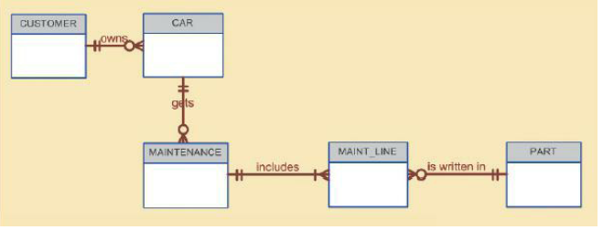

Given the conceptual model in Figure Q4.5:

1. Write the business rules that are reflected in it.

* A customer may or may not own cars
* Each car may only have one owner
* A car may or may not get many maintenance work
* Each maintenance work may only be given to one car
* Maintenance work may include one or more maintenance line
* Each maintenance line belongs to only one maintenance work
* A part may or may not be written in maintenance lines
* Each maintenance line may write in only one part

1. Identify all of the cardinalities.

* Customer (1,1) owns (0,N) Car
* Car (1,1) gets (0,N) Maintenance
* Maintenance (1,1) includes (1,N) Maintenance line
* Part (1,1) is written in (0,N) Maintenance line

7. How would you (graphically) identify each of the following ERM components in a Crow’s Foot

notation?

* 1. an entity



b. the cardinality (0,N) – placed in a text box near the ends of the relationship



c. a weak relationship – dashed line



d. a strong relationship – solid line



8. Discuss the difference between a composite key and a composite attribute. How would each be

indicated in an ERD?

* A composite attribute is an attribute that can be further subdivided to yield additional attributes (for example, EMP_ADDRESS can be subdivided into EMP_ZIP_CODE, EMP_CITY, EMP_PROVINCE)
* Composite key is a **KEY** that is composed of more than one attribute
* Composite keys are depicted as primary key and separated from other attributes in Crow’s Foot Model and labelled as PK/underlined while a composite attribute may be depicted similar to other attributes

10. What is a derived attribute? Give an example.

* Derived attribute is an attribute whose value is calculated from other attributes
* For example, an employee’s age (EMP_AGE) can be calculated by subtracting EMP_DOB (date of birth) from current date

17. Write the 10 cardinalities that are appropriate for this ERD.

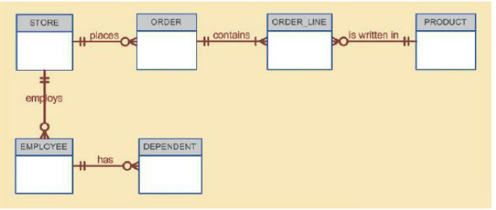

* Employee (1,1) has (0,N) dependent
* Store (1,1) employs (0,N) employee
* Store (1,1) places (0,N) order
* Order (1,1) contains (1,N) order line
* Product (1,1) is written in (0,N) order line

18. Write the business rules reflected in this ERD.

* An employee may or may not have dependents
* Each dependent belongs to only one employee
* A store may or may not employ employees
* An employee is employed by only one store
* A store may or may not place orders
* An order is placed by only one store
* An order may contains one or more lines
* Each line is contained in only one order
* A product may or may not be written in order lines
* Each order line is written for only one product

20. Describe precisely the composition of the DEPENDENT weak entity’s primary key. Use proper

terminology in your answer.

* A DEPENDENT weak entity’s primary key is a composite primary key that contains the primary key of the entity it is dependent upon, the primary key of the entity it is dependent upon is also a foreign key in the DEPENDENT weak entity

Problems:

1. Use the following business rules to create a Crow’s Foot ERD. Write all appropriate

connectivities and cardinalities in the ERD.

* A department employs many employees, but each employee is employed by only one

department.

* Some employees, known as “rovers,” are not assigned to any department.
* A division operates many departments, but each department is operated by only one division.
* An employee may be assigned many projects, and a project may have many employees

assigned to it.

* A project must have at least one employee assigned to it.
* One of the employees manages each department, and each department is managed by only one

employee.

* One of the employees runs each division, and each division is run by only one employee.



6. Automata, Inc. produces specialty vehicles by contract. The company operates several

departments, each of which builds a particular vehicle, such as a limousine, a truck, a van, or an

RV.

• Before a new vehicle is built, the department places an order with the purchasing department

to request specific components. Automata’s purchasing department is interested in creating a

database to keep track of orders and to accelerate the process of delivering materials.

• The order received by the purchasing department may contain several different items. An

inventory is maintained so the most frequently requested items are delivered almost immediately.

When an order comes in, it is checked to determine whether the requested item is in inventory. If an item is not in inventory, it must be ordered from a supplier. Each item may have several suppliers.

Given that functional description of the processes at Automata’s purchasing department, do the

following:

1. Identify all of the main entities.

CONTRACT, VEHICLES, DEPARTMENT, ORDER, COMPONENTS, INVENTORY, SUPPLIER

b. Identify all of the relations and connectivities among entities.



1. Identify the type of existence dependence in all the relationships.

CONTRACT specifies VEHICLES – STRONG

DEPARTMENT makes VEHICLES – STRONG

All other relationships – weak

1. Give at least two examples of the types of reports that can be obtained from the database.
   * Inventory count – determine what components are in stock
   * Department profitability – determine which departments have the most contracts